**RESUME**

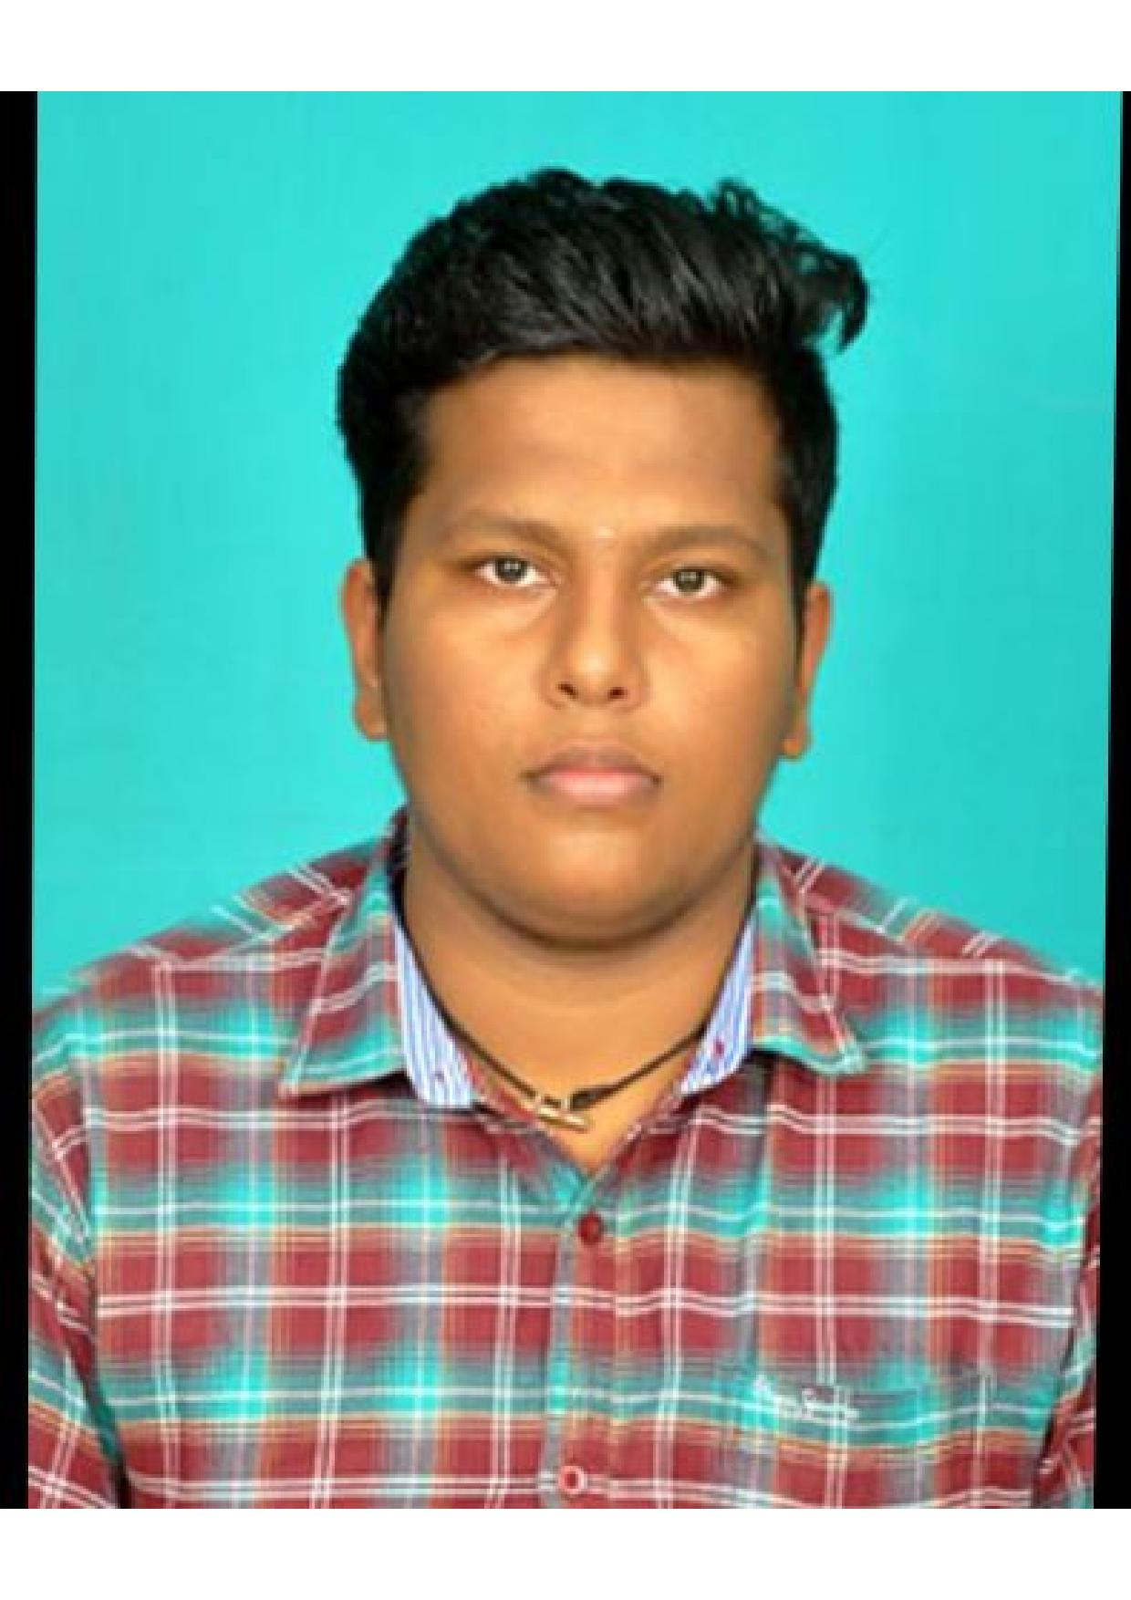

**AJITH M.**

**S/o N MOORTHY,**

**20/14Muthalimar North Street,**

**Near Xavier Church, Kottar (Post),**

**Nagercoil -2, Kanyakumari (Dist).**

**Mobile No: +91 9791509031**

**Email id:ajithmoorthy2212@gmail.com**

**CAREER OBJECTIVE**

To associate myself with an organization that provides a challenging job and an opportunity to prove innovate skills and diligent work.

**EDUCATION DETAILS**

***EDUCATION QUALIFICATION***

|  |  |  |  |  |  |
| --- | --- | --- | --- | --- | --- |
| *Course* | *Institution* | *Medium* | *University / Board* | *Year of Passing* |  |
| S.S.L.C | ST Xavier High School, Nagercoil. | Tamil | Tamilnadu State Board | 2014 |  |
| H.S.C | DVD Hr Sec School, Nagercoil | Tamil | Tamilnadu State Board | 2016 |  |
| B.E  (Mechanical) | ST Xavier’s catholic college of Engineering, Nagercoil. | English | Anna University | 2020 |  |

**EXPERIENCE**

* SITE ENGINEER. JUN 20-JULY21

VAIGAI STEEL ROOFING SYSYEM, COIMBATORE.

**COMPUTER SKILLS**

* DCA (Diploma in Computer Application)
* AUTO CAD
* CREO

**PERSONAL SKILLS**

* Sincerity & Punctuality
* Self Motivated
* Positive Attitude

**HOBBIES**

***HOBBIES***

* Playing Cricket
* Listening Music

**PERSONAL PROFILE**

*Fathers Name* : **MOORTHY N**

*Date of Birth*  : 15/02/1999

*Gender* : Male

*Marital Status* : Single

*Nationality* : Indian

*Languages Known* : Tamil, Malayalam & English

***DECLARATION***

I hereby declare that the about furnished details are true to the best of my knowledge and belief.

***Place***: Nagercoil ***Signature***

***Date*:**

**( AJITH M )**